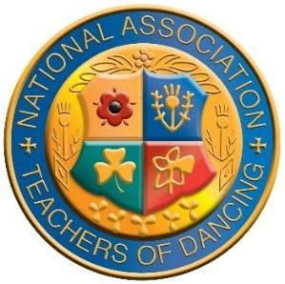
National Association of Teachers of Dancing
North East Area
Inter Schools Competition Day
Sunday 10th October 2021
Whitby Spa Pavilion, West Cliff, Whitby YO21 3EN
Doors Open 9am, First Round 10am Tickets £12.00

 | BALLROOM |  | LATIN |  | SOLO EVENTS
1 | 5yrs & under Waltz | 16 | 5yrs & under Cha Cha | 31 | Under 8yrs Solo - Waltz
2 | 6-7yrs Waltz | 17 | 6-7yrs Jive | 32 | Under 12yrs Solo - Waltz
3 | 8-9yrs Quickstep | 18 | 8-9yrs Jive | 33 | Under 16yrs Solo - Quickstep
4 | 10-11yrs Tango | 19 | 10-11yrs Samba
5 | All Girls under 12yrs Quickstep | 20 | All Girls under 12rs  Cha Cha | 34 | Under 8yrs Solo – Cha Cha
6 | Under 12yrs Open  Waltz & Tango | 21 | Under 12yrs Open  Rumba & Jive | 35 | Under 12yrs Solo - Jive
7 | 12-13yrs Waltz | 22 | 12-13yrs Jive | 36 | Under 16yrs Solo - Samba
8 | 14-15yrs Foxtrot | 23 | 14-15yrs Cha Cha
9 | Under 16yrs Open  Waltz & Tango | 24 | Under 16yrs Open  Samba & Jive
10 | All Girls under 16yrs Quickstep | 25 | All Girls Under 16yrs  Cha Cha
11 | Under 35yrs Quickstep | 26 | Under 35yrs Samba
12 | 35-50yrs Tango | 27 | 35-50yrs Cha Cha
13 | Over 50yrs Waltz | 28 | Over 50yrs Rumba
14 | Open Adult  Waltz & Quickstep | 29 | Open Adult  Rumba & Jive
15 | All Ladies Quickstep | 30 | All Ladies Cha Cha

*Three Independent Adjudicators
*Dress, and Figure Restrictions for Juvenile's only.
*Please do not enter if registered or compete in the open circuit.
*Solo competitions are only for dancers without a partner & must be danced without any assistance.
*No photographs, or the use of any recording equipment is permitted whilst dancers are dancing. *Photograph’s may be taken during the presentation ceremony
Tickets Available from Area Secretary Julie Herrick julieherrick@hotmail.com
07763112826

